1)webapp

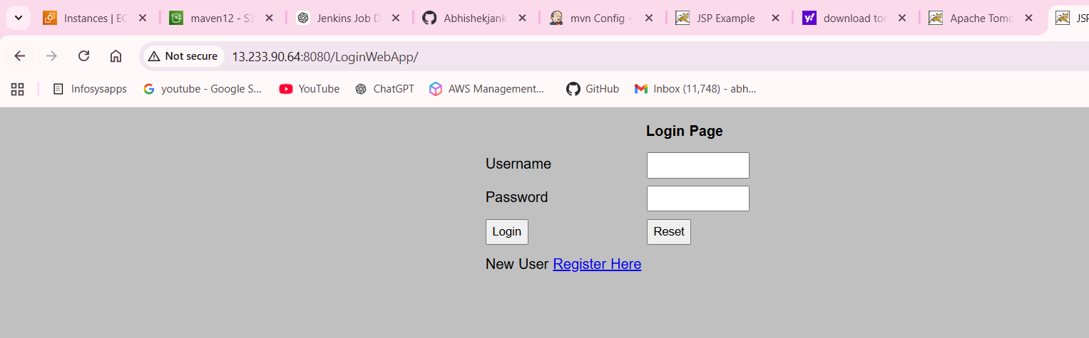

2)configuration

scp -r -i /var/key.pem target/LoginWebApp.war ec2-user@13.233.90.64:/mnt/server/apache-tomcat-10.1.52/webapps/
ssh -i /var/key.pem ec2-user@13.233.90.64 -yes "sh /mnt/server/apache-tomcat-10.1.52/bin/startup.sh"

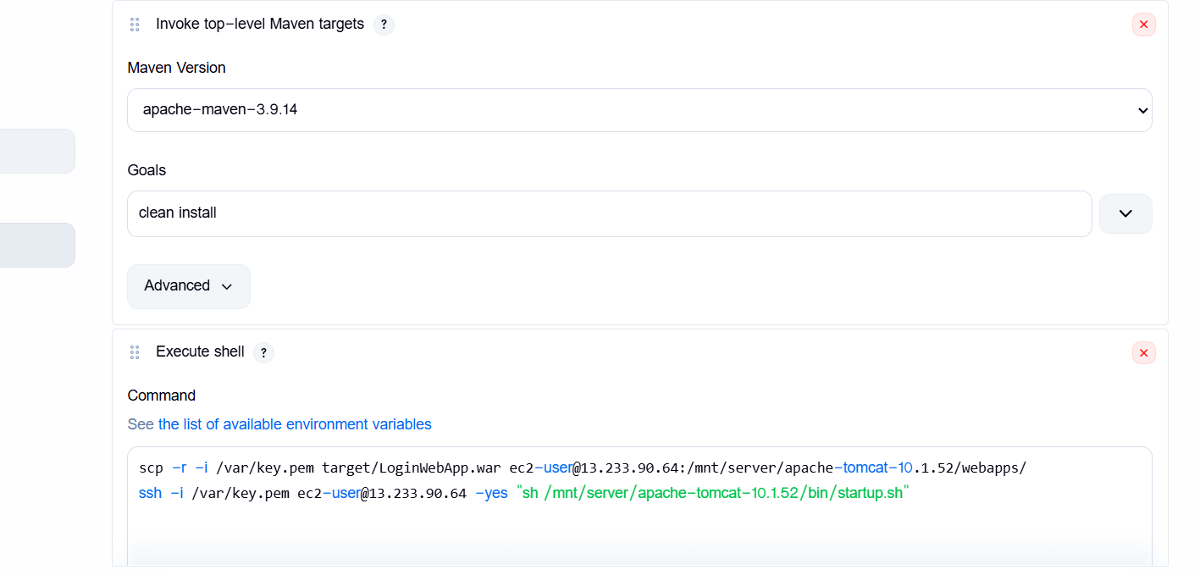

3)machines
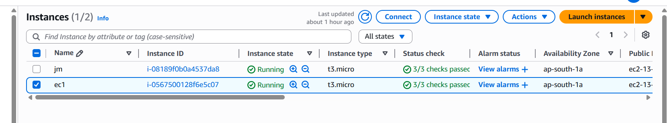

4)console output
